SSAS cube backup Strategies

There are different ways to take Cube database backups.

  - SQL Agent Job
    - XMLA script for backup
  - ROBOT job
    - ASCMD command
  - SSIS Package
    - SSIS package
  - AMO (Analysis Management Objects)
    - PowerShell Scripts

I feel AMO (Analysis Management Objects) does our job much easier and different ways of taking backup is explained below.
I’ve executed the Power Shell scripts from my local PC which connects to remote server and place the backup files (*.abf) on its corresponding backup folder (Default location For eg:- F:\Program Files\Microsoft SQL Server\MSSQL.1\OLAP\Backup\ + Servername).

Pre-requisites
- Load modules if it’s not loaded automatically. Please refer my previous post
- Create a folder with a same name as that of server in a default backup location
For example -
F:\Program Files\Microsoft SQL Server\MSSQL.1\OLAP\Backup\AQBIPT01\
Default location - F:\Program Files\Microsoft SQL Server\MSSQL.1\OLAP\Backup
Folder Created Manually – AQBIPT01

This is continuation of my previous post.

http://www.sqlservercentral.com/blogs/powersql-by-prashanth-jayaram/2013/05/15/ssas-find-cube-database-name-sizestatus-and-total-size-of-ssas-server/

Please do a complete testing on any of your test server.

Logical Flow

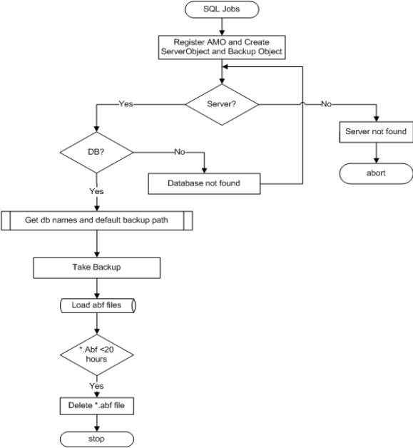

First Method: Cube Database Iteration

The database cube names are listed in c:\SSAS\CubeList.txt file and PowerShell script and traverse through each cube database for backup.

CubeList.txt contains the following the cube databases

ABC
DEF
GHI

PS C:\SSAS> .\SSAS1.PS1 <ServerName>
PS C:\SSAS> .\SSAS1.PS1 AQBIPT01

Copy and Paste code into SSAS1.PS1.

********************************************************

Param($ServerName="localhost")
$loadInfo = [System.Reflection.Assembly]::LoadWithPartialName("Microsoft.AnalysisServices") | Out-Null
## Add the AMO namespace
[Microsoft.AnalysisServices.BackupInfo]$serverBackup = New-Object ([Microsoft.AnalysisServices.BackupInfo])
[Microsoft.AnalysisServices.Server]$server = New-Object Microsoft.AnalysisServices.Server
$server.connect($ServerName)

If ($server.name -eq $null)
{
Write-Output ("Server '{0}' not found" -f $ServerName)
break
}

$DBList = Get-Content "c:\SSAS\CubeList.txt"
Foreach($DBName in $DBList)
{
$DB = $server.Databases.FindByName($DBName)
if ($DB -eq $null)
{
Write-Output ("Database '{0}' not found" -f $DBName)
}
else
{
Write-Output("----------------------------------------------------------------")
Write-Output("Server : {0}" -f $Server.Name)
Write-Output("Database: {0}" -f $DB.Name)
Write-Output("DB State: {0}" -f $DB.State)
Write-Output("DB Size : {0}MB" -f ($DB.EstimatedSize/1024/1024).ToString("#,##0"))
Write-Output("----------------------------------------------------------------")

$BackupDestination=$server.ServerProperties.Item("BackupDir").value
$serverBackup.AllowOverwrite = 1
$serverBackup.ApplyCompression = 1
$serverBackup.BackupRemotePartitions = 1
if (-not $backupDestination.EndsWith("\"))
{
$backupDestination += "\"
}

[string]$backupTS = Get-Date -Format "yyyyMMddHHmm"
$serverBackup.file = $backupDestination + $db.name + "_" + $backupTS + ".abf"
$serverBackup.file
$db.Backup($serverBackup)
if ($?) {"Successfully backed up " + $db.Name + " to " + $serverBackup.File }
else {"Failed to back up " + $db.Name + " to " + $serverBackup.File }

}

}

$server.Disconnect()

Second Method: Passing Cube Server and Database as a paramters

Call it through SSMS/SQL Job/PowerShell Console from any machine where server name and database names are passed as its parameters.

PS C:\SSAS> .\SSAS2.PS1 <ServerName> ‘<DatabaseName>’

PS C:\SSAS> .\SSAS2.PS1 AQBITP01 ‘PROD_OLAP’

Copy and Paste code into SSAS2.PS1.

**************
# Add the AMO namespace
$loadInfo = [System.Reflection.Assembly]::LoadWithPartialName("Microsoft.AnalysisServices") | Out-Null
[Microsoft.AnalysisServices.BackupInfo]$serverBackup = New-Object ([Microsoft.AnalysisServices.BackupInfo])
[Microsoft.AnalysisServices.Server]$server = New-Object Microsoft.AnalysisServices.Server
$server.connect($ServerName)
if ($server.name -eq $null) {
Write-Output ("Server '{0}' not found" -f $ServerName)
break
}

$DB = $server.Databases.FindByName($DBName)
if ($DB -eq $null) {
Write-Output ("Database '{0}' not found" -f $DBName)
break
}

Write-Output("----------------------------------------------------------------")
Write-Output("Server : {0}" -f $Server.Name)
Write-Output("Database: {0}" -f $DB.Name)
Write-Output("DB State: {0}" -f $DB.State)
Write-Output("DB Size : {0}MB" -f ($DB.EstimatedSize/1024/1024).ToString("#,##0"))
Write-Output("----------------------------------------------------------------")

$BackupDestination=$server.ServerProperties.Item("BackupDir").value
$serverBackup.AllowOverwrite = 1
$serverBackup.ApplyCompression = 1
$serverBackup.BackupRemotePartitions = 1
if (-not $backupDestination.EndsWith("\"))
{
$backupDestination += "\"
}

[string]$backupTS = Get-Date -Format "yyyyMMddTHHmm"
$serverBackup.file = $backupDestination +$servername+'\'+ $db.name + "_" + $backupTS + ".abf"
$serverBackup.file
$db.Backup($serverBackup)
if ($?) {"Successfully backed up " + $db.Name + " to " + $serverBackup.File }
else {"Failed to back up " + $db.Name + " to " + $serverBackup.File }
$server.Disconnect()

********************************

Run the T-SQL on SSMS or SQL Job:

master..xp_cmdshell 'PowerShell.exe c:\SSAS_Backup.PS1 AQBITP01 ''PROD_OLAP'''

SQL Job

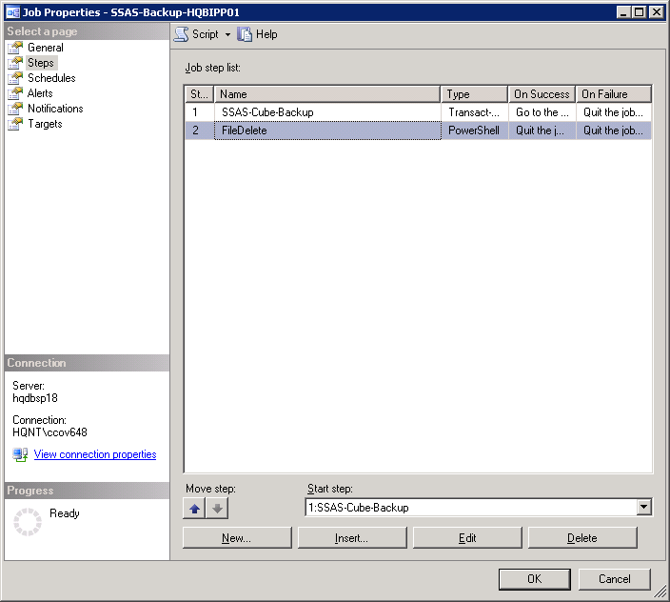

STEP1: master..xp_cmdshell 'PowerShell.exe c:\SSAS_Backup.PS1 AQBITP01 ''PROD_OLAP'''

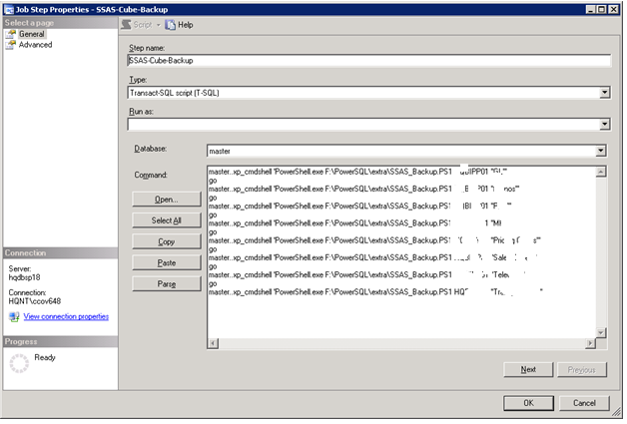

STEP 2: Delete backup files – Copy and Paste the below code
***********************
Function filedelete
{
Param($ServerName="localhost")
$loadInfo = [System.Reflection.Assembly]::LoadWithPartialName("Microsoft.AnalysisServices") | Out-Null
[Microsoft.AnalysisServices.BackupInfo]$serverBackup = New-Object ([Microsoft.AnalysisServices.BackupInfo])
[Microsoft.AnalysisServices.Server]$server = New-Object Microsoft.AnalysisServices.Server
$server.connect($ServerName)
if ($server.name -eq $null) {
Write-Output ("Server '{0}' not found" -f $ServerName)
break
}
$BackupDestination=$server.ServerProperties.Item("BackupDir").value
if (-not $backupDestination.EndsWith("\"))
{
$backupDestination += "\"
}

[string]$backupTS = Get-Date -Format "yyyyMMddTHHmm"
$serverBackup.file = $backupDestination +$servername+'\'+ $db.name + "_" + $backupTS + ".abf"
#write-host $serverBackup.file
$server.Disconnect()
$drive=$serverBackup.file.substring(0,1)
#write-host $drive
$Ppath=$backupDestination +$servername
#write-host $Ppath
$path=$Ppath | Measure-Object -Character |select characters
$len=$path.characters
#write-host $len
$path=$serverBackup.file.substring(2,$len-1)
#write-host $path
$file=get-ChildItem \\$servername\$Drive$\$path -Filter *.abf | Select-object LastWriteTime,directoryname,name | where-object {$_.LastWriteTime -lt [System.DateTime]::Now.Addhours(-20)}
#write-host $file
foreach($f in $file)
{
$filename=$f.directoryname+'\'+$f.name
write-output 'File can be deleted' $filename
remove-item $filename -Force
}
}

Filedelete HQBIPP01
********************************************

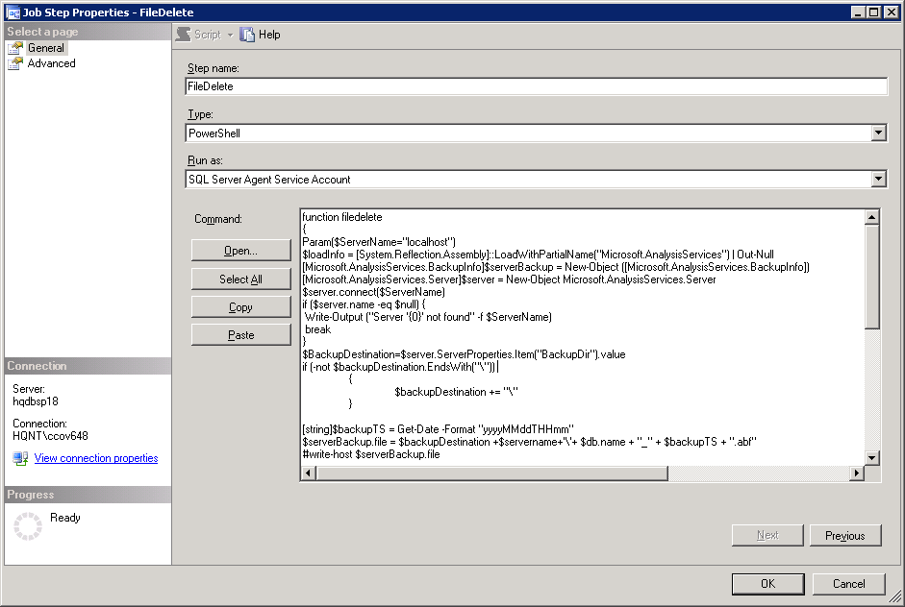

Output:-
----------------------------------------------------------------
Server : AQBITP01
Database: PROD_OLAP
DB State: Processed
DB Size : 2MB
----------------------------------------------------------------
F:\Program Files\Microsoft SQL Server\MSSQL.1\OLAP\Backup\PROD_OLAP_201305210819.
abf
Successfully backed up Telecom to F:\Program Files\Microsoft SQL Server\MSSQL.1
\OLAP\Backup\PROD_OLAP_201305210819.abf
NULL

