Today I got a chance to retrive some configuration information of a sql server 2005. PowerShell provide a facility to read the registry information with ease.The PowerShell treats the registry like any other location or directory. One critical difference is that every item on a registry-based Windows PowerShell drive is a container, just like a folder on a file system drive.

In this post I’m simulating the sys.dm_server_registry DMV using Powershell.
This code can be enhanced to various levels that meet your requirement and it’s applicable to SQL Server 2005 onwards.

DMV - sys.dm_server_registry

It will display a configuration and installation information that is stored in the Windows registry for the current instance of SQL Server

SELECT * FROM sys.dm_server_registry
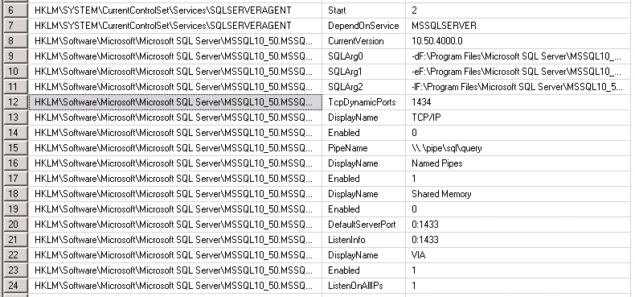

PowerShell Script to read Registry data

function Get-RemoteRegistryKeyProperties
{
param(
$computer = $(throw "Please specify a computer name."),
$path = $(throw "Please specify a registry path"),
$property = "*"
)

## Validate and extract out the registry key
if($path -match "^HKLM:\\(.*)")
{
$baseKey = [Microsoft.Win32.RegistryKey]::OpenRemoteBaseKey(
"LocalMachine", $computer)
}
else
{
Write-Error ("Please specify a fully-qualified registry path " +
"(i.e.: HKLM:\Software) of the registry key to open.")
return
}

## Open the key
$key = $baseKey.OpenSubKey($matches[1])
$returnObject = New-Object PsObject

## Go through each of the properties in the key
foreach($keyProperty in $key.GetValueNames())
{
## If the property matches the search term, add it as a
## property to the output
if($keyProperty -like $property)
{
$returnObject |
Add-Member NoteProperty $keyProperty $key.GetValue($keyProperty)
}
}

## Return the resulting object
$returnObject
}
Function Get-ReadSQLRegistryEntries ($computer)
{
$OS = (Get-WmiObject Win32_OperatingSystem -computername $computer).caption
$SystemInfo = Get-WmiObject -Class Win32_OperatingSystem -computername $computer | Select-Object Name, TotalVisibleMemorySize, FreePhysicalMemory
$a=Get-RemoteRegistryKeyProperties $COMPUTER 'HKLM:\Software\Microsoft\Microsoft SQL Server\Instance Names\SQL' "MSSQLSERVER"
$path='HKLM:\Software\Microsoft\Microsoft SQL Server\'+$a.MSSQLSERVER+ '\MSSQLServer\Parameters'
$Serverstartup=Get-RemoteRegistryKeyProperties $COMPUTER 'HKLM:\SYSTEM\CurrentControlSet\SERVICES\MSSQLSERVER' "START"
$ServerAgentstartup=Get-RemoteRegistryKeyProperties $COMPUTER 'HKLM:\SYSTEM\CurrentControlSET\SERVICES\SQLSERVERAGENT' "START"
$ServerAc=Get-RemoteRegistryKeyProperties $COMPUTER 'HKLM:\SYSTEM\CurrentControlSET\SERVICES\MSSQLSERVER' "ObjectName"
$SAC=$ServerAC.ObjectName
$ServerAgAc=Get-RemoteRegistryKeyProperties $COMPUTER 'HKLM:\SYSTEM\CurrentControlSET\SERVICES\SQLSERVERAGENT' "ObjectName"
$SAG=$ServerAgAC.ObjectName
$ErrorLog=Get-RemoteRegistryKeyProperties $COMPUTER $path "SQLArg1"
$E=$ErrorLog.SQLArg1
$DataPath=Get-RemoteRegistryKeyProperties $COMPUTER $path "SQLArg0"
$DP=$DataPath.SQLArg0
$LogPath=Get-RemoteRegistryKeyProperties $COMPUTER $path "SQLArg2"
$LP=$LogPath.SQLArg2
$Domain=Get-RemoteRegistryKeyProperties $COMPUTER 'HKLM:\SYSTEM\ControlSET001\Services\Tcpip\Parameters' "DOMAIN"
$D=$Domain.Domain
$lib=Get-RemoteRegistryKeyProperties $COMPUTER 'HKLM:\SOFTWARE\Microsoft\MSSQLServer\Setup' "SQLPath"
$SQL=$lib.SQLPath
$Port=Get-RemoteRegistryKeyProperties $COMPUTER 'HKLM:\Software\Microsoft\MSSQLServer\MSSQLServer\SuperSocketNetLib\TCP' "TcpPort"
$P=$Port.TcpPort
$registry_key = 'HKLM:\Software\Microsoft\Microsoft SQL Server\' +$a.MSSQLSERVER+ '\MSSQLServer'
$AuditLevel=Get-RemoteRegistryKeyProperties $COMPUTER $registry_key "auditlevel"
$loginMode=Get-RemoteRegistryKeyProperties $COMPUTER $registry_key "loginmode"

switch ($Serverstartup.start)
{
2 {$ServerStartup = "Automatic"}
3 {$ServerStartup = "Manual"}
4 {$ServerStartup = "Disabled"}
}

switch ($ServerAgentstartup.start)
{
2 {$ServerAgentstartup = "Automatic"}
3 {$ServerAgentstartup = "Manual"}
4 {$ServerAgentstartup ="Disabled"}
}
switch ($auditLevel.auditLevel)
{
0 {$Value="None."}
1 {$value="Successful Logins Only"}
2 {$value="Failed Logins Only."}
3 {$value="Both Failed and Successful Logins Only"}

}
switch($loginMode.loginmode)
{
1 {$Log="Windows Authentication"}
2 {$Log ="SQL Server Authentication"}
}
$OutputObj = New-Object -Type PSObject
$OutputObj | Add-Member -MemberType NoteProperty -Name serverName -Value $computer.ToUpper()
$OutputObj | Add-Member -MemberType NoteProperty -Name OS -Value $OS
$OutputObj | Add-Member -MemberType NoteProperty -Name SQLPATH -Value $SQL
$OutputObj | Add-Member -MemberType NoteProperty -Name DataPath -Value $DP
$OutputObj | Add-Member -MemberType NoteProperty -Name LOGPath -Value $LP
$OutputObj | Add-Member -MemberType NoteProperty -Name ERRORLOG -Value $E
$OutputObj | Add-Member -MemberType NoteProperty -Name Domain -Value $d
$OutputObj | Add-Member -MemberType NoteProperty -Name Port -Value $P
$OutputObj | Add-Member -MemberType NoteProperty -Name SERVERSTARTUP -Value $ServerStartup
$OutputObj | Add-Member -MemberType NoteProperty -Name AGENTSTARTUP -Value $ServerAgentstartup
$OutputObj | Add-Member -MemberType NoteProperty -Name STARTUPACCOUNTSERVER -Value $SAC
$OutputObj | Add-Member -MemberType NoteProperty -Name STARTUPACCOUNTAGENT -Value $SAG
$OutputObj | Add-Member -MemberType NoteProperty -Name AUDITDETAIL -Value $Value
$OutputObj | Add-Member -MemberType NoteProperty -Name LOGIN -Value $Log
$OutputObj

}

Function Call to SQL Server 2005
PS F:\PowerSQL\Installation>Get-ReadSQLRegistryEntries hqvd0026
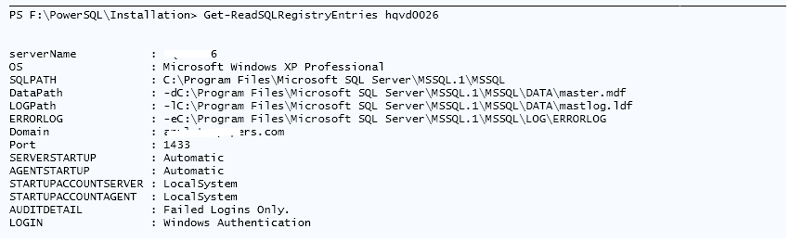

Function Call to SQL Server 2008 R2
PS F:\PowerSQL\Installation>Get-ReadSQLRegistryEntries hqdbsp16
